*Realizing that you are not alone in your fight is your greatest asset as a developer.*

Writing code is one thing, but writing working code is quite another. As a developer, it can occasionally become daunting to write codes and wait for results. Hours could pass and the outcome would remain the same.

[via GIPHY](https://giphy.com/gifs/monstercat-edm-electronic-music-3o72F7RrTPW6jymXew)

If you are feeling stuck, it is time to check out a community.

**WHAT IS A COMMUNITY?**

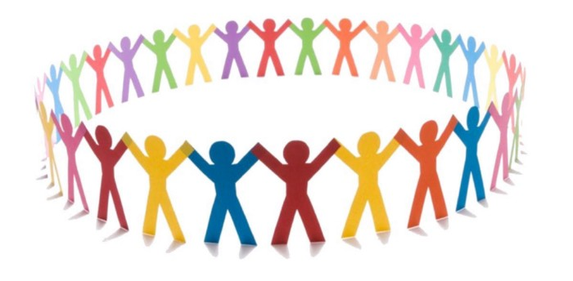

According to [dictionary.com](http://dictionary.com/), a community is a social group whose members have something in common. Such as a shared government, geographic location, and port. It means that people in a community have a common interest. In a tech context, a community is a group of people who share ideas, learn, and grow together for a common goal.

**To network with other like minds and foster individual and career growth. Being in a community helps to build relationships that could solve problems.**

*It is paramount to point out that as a member of a community; a symbolic relationship is best. It means preferably a give-and-take situation that benefits everyone who belongs to the community.*

**TYPES OF COMMUNITIES TO JOIN**

Here are some online communities to check out for help:-

Big Communities

Medium Communities

Gender Focus Communities

Students focused Communities

Expert Communities

Language focused Communities

**BIG COMMUNITIES**

[**Stackoverflow**](https://stackoverflow.com/)

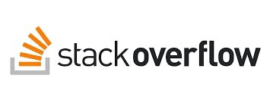

There is a saying to uphold when talking about stack overflow, *What code error stackoverflow can resolve does not exist*.

As its meta description explains ***where developers learn, share, build, and connect***. Stackoverflow is that community that helps you research and give guidance to questions around a particular track of technology. It is diverse.

According to Wikipedia, in March 2021, Stack Overflow has over 14 million registered users. It received over 21 million questions and 31 million answers. The site and similar programming question and answer sites has now replaced programming books for day-to-day programming references in the 2000s and play a vital part in computer programming today.

Another good thing about the community is the variety of opinions and examples to select from.

Simply your question on your search engine, there is a high possibility that your first coding solutions/ recommendations come from it. No matter the programming language, you are sure to get help on the solution.

The top eight most discussed topics on the site are: JavaScript, Java, C#, PHP, Android, Python, jQuery, and HTML.

Stack overflow is that easy to use. Registered or not, you still enjoy the benefits of learning. Stackoverflow is best experienced as a registered member.

On another side of it, you can find job postings. Feel free to check it out.

[**Meta Developers Circle**](https://developers.facebook.com/developercircles/)



Another community to find connection with is Meta developers. It used to be known as Facebook developersCircle . Meta developers is a platform to learn, share ideas, and network with other developers. Members get to receive coaching from technology experts and collaborate with like-minded peers. And take part in a range of building initiatives. Its target is advanced developers and creators. Unlike stack overflow, you need to register with a chapter before you can access it. meaning that a Facebook account is necessary as the community is hosted on the platform.

[Google Developer Group(GDG)](https://developers.google.com/community/gdg)

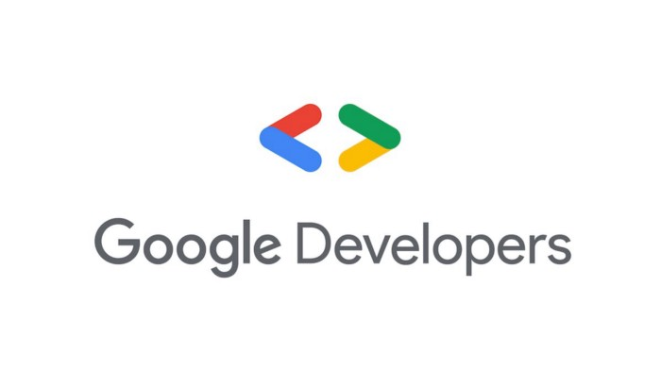

Considered the biggest community due to the level of services it provides. (Small fun facts:->*According to its website, GDG has over 1,000 chapters across 140 countries.*)

GDG is a community that thrives on its commitment to learning, sharing, connecting, and networking. Its goal is to Connect, Learn, and Grow.

**Connect**:- You get to meet local developers and technologists including those with unique backgrounds and from various companies and industries.

**Learn**:- to Learn a range of technical topics and gain new skills. Through hands-on workshops, training, events, talks, and meetups (online and in person).

**Grow**:- Application of knowledge and connections to build great products. That advances your skills, career, and network as well as assists your community to learn too.

Under GDG, there are communities to help members better contribute and meet like-minded. These communities include:- Women tech makers, Google Developer Students Club(GDSC), Google experts, and tech equity collective. All these communities exist to give members bound to find the perfect place for them. Google has other perks for joining its community. They organize programs that benefit their members. Programs include:- Accelerator,Coding Competitions, Solution Challenge and DevFest.

**MEDIUM COMMUNITIES**

[**DEV Community**](https://dev.to/)

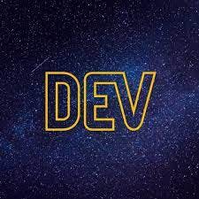

Dev Community stands for developers community.

It is a community where software developers are together to assist one another. Dev Community prides itself on some of the principles of the software industry. Which are Collaboration and network learning. (Cool fact:- > Dev Community has 897,181 amazing developers.) The Community believes in transparency and adding value to the ecosystem.

[**For loop Africa**](https://forloop.africa/)

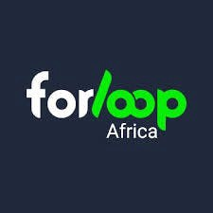

One of the largest tech communities in Africa. It began as a community for Nigerian developers in 2016 to promote developers unity. For loop has chapters in different states across Nigeria and other African countries like Ghana, Kenya, Morocco, Rwanda, Tanzania, Uganda, and Zimbabwe, among others.

[**Open source community Africa (OSCA)**](https://oscafrica.org/)

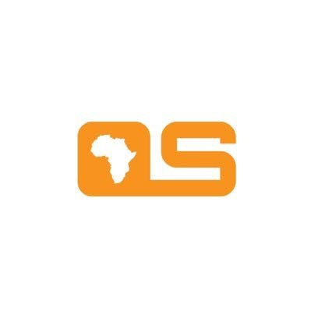

OSCA aims to grow and improve the number of credible contributions and development of open source technologies from African software developers and designers. Its mission is to encourage a diverse community of open source lovers, to collaborate on different projects to make a difference across Africa. Currently, OSCA has four arms to achieve its mission.

They include:- OSCA Chapters, Open Source Festival, and featured open source projects.

[**Dev Career (Developers Career)**](https://devcareer.io/)

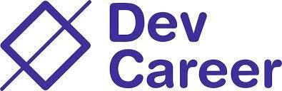

DevCareer is a non-profit organization with the main aim of supporting underrepresented tech talents. Its goal is to provide newbies starting in tech access to relevant resources to ease their learning journey.

It aims to create employment and promote innovative ideas.

[**Codenovation**](https://codenovation.org/)

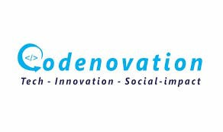

Condenovation is a community of developers on a mission to give back to society. It organizes meetups for young people to learn programming and other technology skills. It believes in using technology to promote social impact.

[**DevOps NG**](https://devops.ng/)

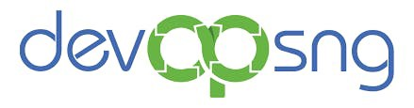

It is a community that combines Software, DevOps, Cloud and Site Reliability Engineers, and IT experts in Africa. The community promotes Continuous Learning with its open learning culture. It shares job opportunities and gives back to the community.

[**Adaora Hack Study Groups**](https://adorahack.com/)

The AdoraHack study group is a space for newbies to learn and collaborate on technical topics. The fields include:-Frontend development, backend development, DevOps, etc.

[**Ingressive for Good (IG4)**](https://ingressive.org/)

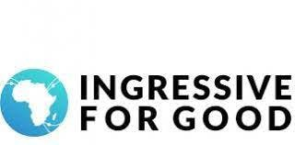

I4G Circle is a community in cities across Africa that leverages technology to solve problems in society. Its mission is to Inspire, Empower, and Connect African Youth in Tech through programs, scholarships,workshops, and training. IG4 Core Value is an acronym for HACK that stands for Help others, Add value, Connect, and Keep Growing. It is led by I4G Ambassadors and they work together to build an active community of tech enthusiasts and creators.

**GENDER FOCUS COMMUNITIES**

[**Women in Tech Nigeria (We Tech NG)**](https://www.wetechng.com/)

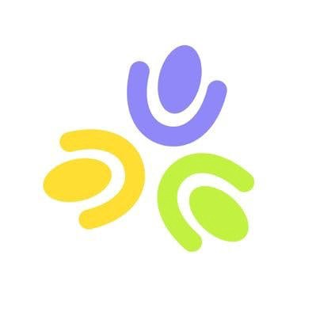

Launched in 2018, We Tech believes in access and providing communities. It aims at driving women into tech spaces through networks, programs, and community building. We tech four pillars to include:-

**Network**:- through intersecting community with industry and students via its conferences.

**Programs**:- organize programs and workshops to give the community access to resources.

**Community**:- it believes that a support system aids growth.

**Technology**:- It affirms that a diverse tech builds the best in Technology.

It holds a physical conference this week in Lagos, Nigeria. It is free.

[**SheCode Africa(SCA)**](https://shecodeafrica.org/)

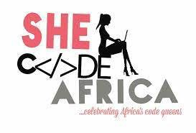

SCA is a non-profit organization focused on empowering young girls and women in Africa through technical skills. Founded SCA in 2016, the community has impacted over 17,000 women members across 20 African countries.

It champions gender diversity in tech. Its core goals include:- teamwork community, leadership, visibility, and technical growth.

The SCA community organizes events such as the SCA fest for its members to rub their minds, share ideas, and celebrate their accomplishments with keynote speakers to speak on assigned topics.

SCA also organizes mentorship and training programs for its members with professional guidance and monitored growth. Their goal is to see an Africa where women are represented across all career roles in tech.

Its mission is to build a community that embodies technical growth through networking, mentorship, and visibility among all levels and career roles in tech.

[Women Techmakers](https://developers.google.com/womentechmakers)

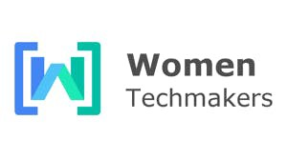

Google’s Women Techmakers program provides visibility and community. Resources for women in technology. Its mission is to build a world where all women can thrive in technology.

[**Digi Girls Africa**](https://cybersafefoundation.org/digigirls/)



It is an e-learning platform to teach and train women and girls on how they can navigate and thrive in the digital revolution. Established in 2018, it hosts workshops and boot camps for teenagers and young women.

Digi Girls Africa is passionate about building an accessible and inclusive digital economy for women in Africa by providing them with relevant digital skills and knowledge to access information. Secure economic opportunities, and contribute to achieving SDGs 4, 8, 9, and 10.

Its Core values are care economy, call-in culture, humanocracy, access, inclusion, community, collaboration, and digital hygiene.

**STUDENTS FOCUSED COMMUNITIES**

[**GDSC- Google Developers Students Clubs**](https://developers.google.com/community/gdsc)



A Google community Initiative for Students. GDSC welcomes students with an interest in becoming developers from any course of students. The key goal of joining GDSC is to encourage students to build solutions for local business and their communities. It organizes meetups(online and in person),workshops & training for its members.

[**IG4 Students Circles**](https://ingressive.org/i4g-circle/) The goal of IG4 Students circles is to use tech to solve problems. It organizes workshops, talks, and training for its members. Find a chapter on campus to join.

**Student Community but gender-focused.**

[**SCA Campus Chapters**](https://shecodeafrica.org/chapters) In line with the SCA organization goals, the SCA campus chapter fosters a community for female students in different to learn, collaborate and solve problems using tech skills. It promotes visibility for its members as well as organizes meetups for members.

**EXPERT COMMUNITIES**

[**Google Developer Experts**](https://developers.google.com/community/experts)

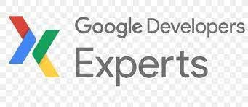

Another Google Initiative, the Google Developer Experts is a global network of experienced technical experts, influencers, and thought leaders who have expertise in Google technologies, who are active leaders in the community, natural mentors, and who contribute to the developer and startup ecosystem.

[**Atos Expert Community**](https://atos.net/en/about-us/innovation-and-research/atos-expert-community)

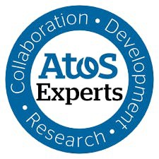

With 2400 members across the globe, the Atos Expert Community driving force is technical collaboration, ideation, and innovative research and development. Its experts help to steer business strategy; building an R&D roadmap by anticipating technology trends that will enable products and services that will be needed by the market. Atos Expert specializes in a wide range of subjects which it categorizes eight technologies which include:-: advanced computing (including quantum), artificial intelligence, automation, cybersecurity, edge, hybrid cloud, immersive experience, and modern applications.

**LANGUAGE FOCUSED COMMUNITIES**

[**Kotlin User Group**](https://kotlinlang.org/community/user-groups/)

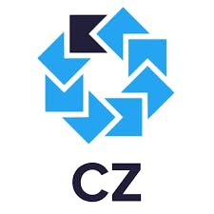

Kotlin User Group is a community for developers that work with the Kotlin programming language. It also provides an opportunity for tech enthusiasts to learn about the programming language.

[**JAMstack**](https://jamstack.org/community/)

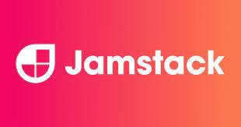

JAMStack is the combination of JavaScript, Application Programming Interface (APIs), and pre-rendered Markups. It aims at encouraging developers to build fast, secure, and dynamic websites and applications. The Community mission is to exchange ideas, find opportunities,and help build a better web.

JAMStack organizes meetups where developers share knowledge in these areas like static site generation, modern web ecosystem, web apps, and web hosting among others.

**Launching Soon**

Tech Equity Collective is an initiative started by Google to speed up Black representation and genius in the tech industry. Tech Equity Collective partners with the Black community of other tech companies and organizations to create holistic pathways for Black tech innovators.

What communities did I miss? Please leave it in the comments box until the next time, and thanks for reading.

Image Sources:- Getty Images& Giphy.